Paul Cézanne (1839-1906)
Paul Cézanne was a French painter, whose innovative techniques and original interpretations of traditional genres made him perhaps the most influential artist in the early history of modernism. Affiliated primarily with POST-IMPRESSIONISM, Cézanne famously declared: “I wanted to make of Impressionism something solid and enduring like the art in the museums.” Along with his Post-Impressionist contemporaries PAUL GAUGUIN, VINCENT VAN GOGH, and GEORGES SEURAT, Cézanne advanced the lessons of the Impressionist painters with whom he was initially affiliated. His grasp of color and composition, however, reflect his study of Éugene Delacroix and Nicolas Poussin. But it was Cézanne’s ability to represent underlying structures in nature while retaining gestural but disciplined brushstrokes that earned him the admiration of artists such as HENRI MATISSE and PABLO PICASSO.

Also see ABSTRACT ART, AVANT-GARDE, GEORGES BRAQUE, CUBISM, PAUL GAUGUIN, HENRI MATISSE, PABLO PICASSO, PASSAGE TECHNIQUE, POST-IMPRESSIONISM, GEORGES SEURAT and VINCENT VAN GOGH.

Career
Cézanne was born in Aix-en-Provence, where – at his father’s behest – he studied law before devoting himself to painting in his early twenties. Dividing his time between Paris and Aix, Cézanne studied at the Académie Suisse and tried twice, but failed to be admitted to the prestigious École des Beaux-Arts. Dark, lurid palettes and perverse subjects of murder and sexual intrigue characterize his early work, examples of which were several times rejected from the official Salon.

At the same time, Cézanne fell in with the Impressionist painters and eventually participated in two of their exhibitions (1874 and 1877). He befriended Camille Pissarro, with whom he painted en plein air; under Pissarro’s tutelage, Cézanne developed several distinctive techniques including the PASSAGE TECHNIQUE. His unique method of overlapping and blending planes to integrate objects in space is especially apparent in his many depictions of Mont Sainte-Victoire near Aix. The technique enabled him to simplify formal relationships in nature without compromising its visual complexity. He also experimented in other traditional genres such as still life and portraiture, creating psychologically opaque self-portraits and depictions of his wife Hortense Fiquet.

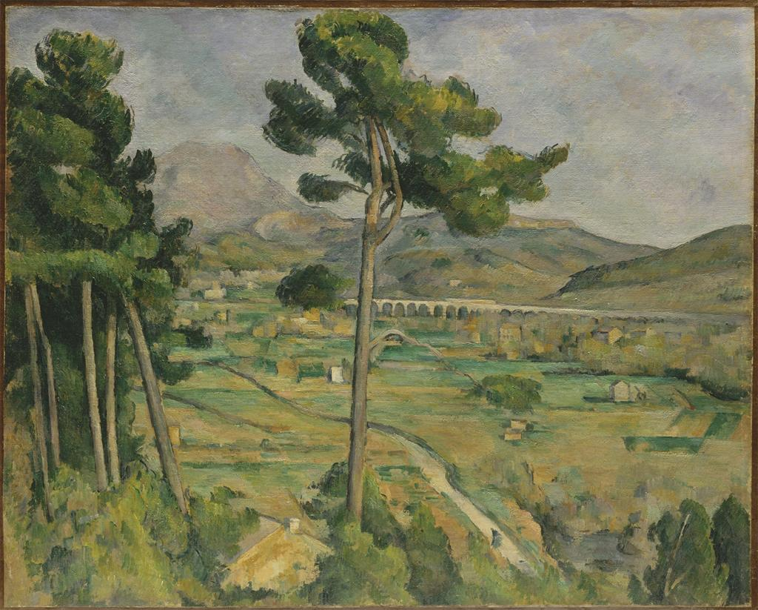 Paul Cézanne, Mont Sainte-Victoire Seen from Bellevue (1882-85)

By the early 1890s, Cézanne had returned to Aix for good. In 1895, he had his first one-man show in the Paris gallery of Ambroise Vollard and in 1904 the Salon d’Automne honored him with a special exhibition. Cézanne’s late work continued his repetitive analysis of motifs in nature; it reveals a distillation of formal relationships that create more expressive and ambiguous content. The most noteworthy and ambitious pictures from this period are his three large-scale Bather paintings that culminated in The Large Bathers from 1906, the year of his death. When the German collector Karl Ernst Osthaus visited the painter’s studio that year, he aptly observed: “The tall shafts of the trees bent down, already forming the cathedral vault beneath which unfolded the scene of bathers.”

Paul Cézanne, The Large Bathers (1906) 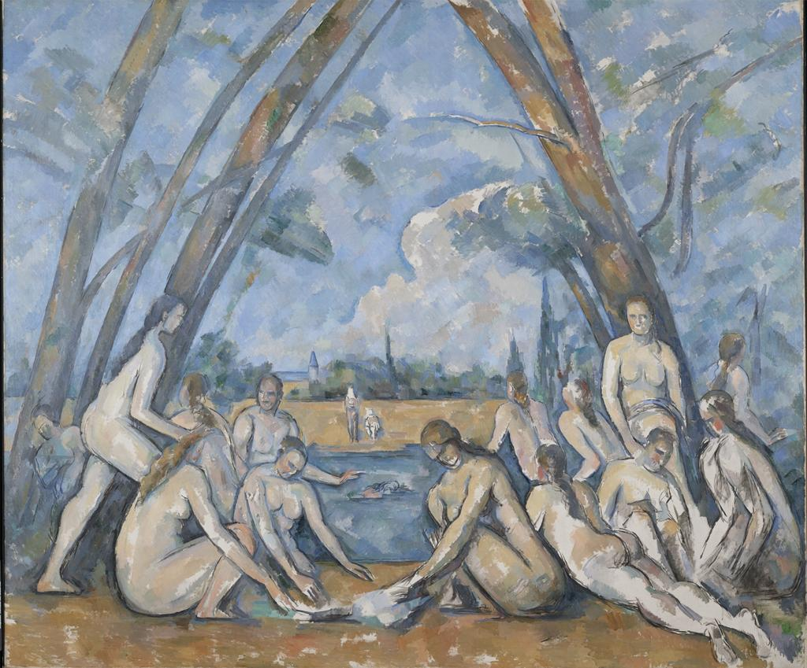

Legacy
In 1907, the Salon d’Automne hosted a memorial retrospective of Cézanne’s work that influenced many AVANT-GARDE painters. This exhibition was a major factor in the development of CUBISM; GEORGES BRAQUE and PABLO PICASSO emulated Cézanne’s PASSAGE TECHNIQUE to fracture form and depict many views of the same subject simultaneously. HENRI MATISSE, who called Cézanne “a god of painting,” admired the bathers, and VASILY KANDINSKY credited Cézanne with anticipating ABSTRACT ART.

Key Reference Works:
Badt, Kurt. Die Kunst Cézannes (1956)
Cachin, Françoise, et. al. Cézanne (1996)
Doran, P. Michael, ed. Conversations avec Cézanne (1978)
Rewald, John. Cézanne: A Biography (1948)
Schapiro, Meyer. Paul Cézanne (1952)

